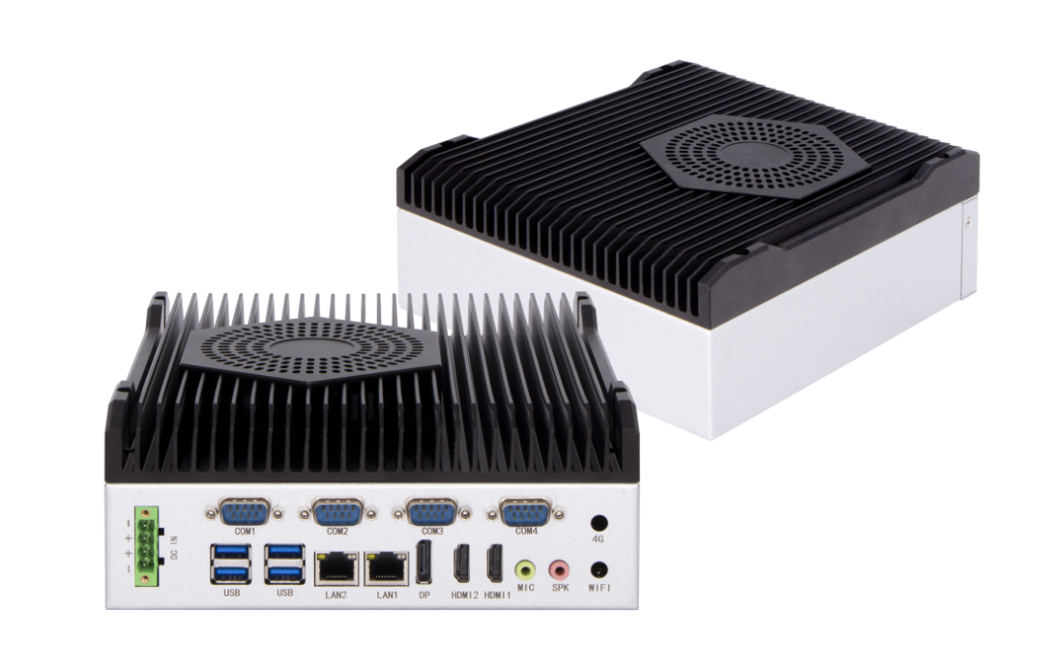
Industrial Mini PC
QY-B5900
Desktop CPU Series

Products Features:
- Industrial-Grade Embedded Fanless Mini PC
- Intel H310 / H610 Chipset
- Intel Celeron, Pentium and Core 8/9/12/13/14th-i3 / i5 / i7 / i9 CPU
- 2*LAN, 4*USB, 4*COM, 2*HDMI, 1*DP
- 2*M.2 Expansion Slots, Support 4G and WIFI Module
- DC 9-36V Power Input With Overvoltage Protection
- -30℃~70℃ Temperature Can Keep 24/7 Work Stably
- Anti-Static, Anti-Pulse, Anti-Surge, Anti-Radiation
QY-B5900
1.Mother Board Specification:
Model | QY-B5900
Chipset | H310 | H610
CPU | Celeron G Series  Pentium G series  Core 8 / 9th-i3 / i5 / i7 / i9 | Celeron G Series  Pentium G series  Core 12 / 13 / 14th-i3 / i5 / i7 / i9
Memory | 2*DDR IIII RAM Slots, Up to 32GB | 2*DDR IIII RAM Slots, Up to 128GB
Storage | 1*M.2 SATA SSD Slot | 1*M.2 NVME SSD Slot
Display | 2*HDMI: Resolution up to 4096*2304@24Hz  1*DP: Resolution up to 4096*2304@60Hz | 1*HDMI: Resolution up to 4096*2304@24Hz  1*VGA: Resolution up to 1920*1200@60Hz
Expansion | 2*M.2 Slots, Support 4G and WIFI module | 1*M.2 Slot, Support WIFI module
Ethernet | 2*Realtek 8111E LAN Chip  (10 / 100 / 1000 Mbps, RJ-45 Type) | 2*Intel i226V LAN Chip  (10 / 100 / 1000 / 2500 Mbps, RJ-45 Type)
USB | 4*USB 3.0 (Type-A) | 4*USB 3.0 (Type-A)  2*USB 2.0 (Type-A)
COM | 2*RS-232 / 422 / 485 (DB9 Type)  2*RS-232 (DB9 Type) | 2*RS-232 / 485 (DB9 Type)
Audio | 1*Line-In+1*Line-Out

QY-B5900
2.Device Specification:
Watch Dog | Support
Power Input | DC 9-36V With Overvoltage Protection
Power Input | Support Auto-Start
Power Input | 4 Pin Phoenix Terminal Type DC Plug
Working Temperature | -30℃~70℃, Support 24/7 Working
Structure | Fully Enclosed Aluminum Alloy Material
Heat Dissipation | Fan Design
Installation | Desktop / Embedded / Wall Mount
Size | 227mm*230mm*82mm
System | Windows and Linux

QY-B5900
3.Ordering Information:
Model | Chipset | LAN | USB | COM | Display | RAM | SSD | Expansion | Power
QY-B5900 | H310 | 2 | 4 | 2*RS-232/422/485  2*RS-232 | 2*HDMI  1*DP | 2*DDR 4  Up to 32GB | 1*M.2 SATA | 2*M.2 | DC 9-36V
QY-B5900 | H610 | 2 | 6 | 2*RS-232/485 | 1*HDMI  1*VGA | 2*DDR 4  Up to 128GB | 1*M.2 NVME | 1*M.2 | DC 9-36V

4.System Information:

Chipset | System
H310  H610 | Windows 10 / 11 and Linux

5.Fittings Information:
RAM | DDR 4 | 4GB / 8GB / 16GB / 32GB
Storage | M.2 SATA/ NVME | 128GB / 256GB / 512GB / 1TB / 2TB / 4TB
GSM Module | 4G | 4G+GPS
WIFI Module | 7260AC / AX210

6.Package List:

Adapter | 1*12V 10A Adapter
Power Cable | 1*Power Cable

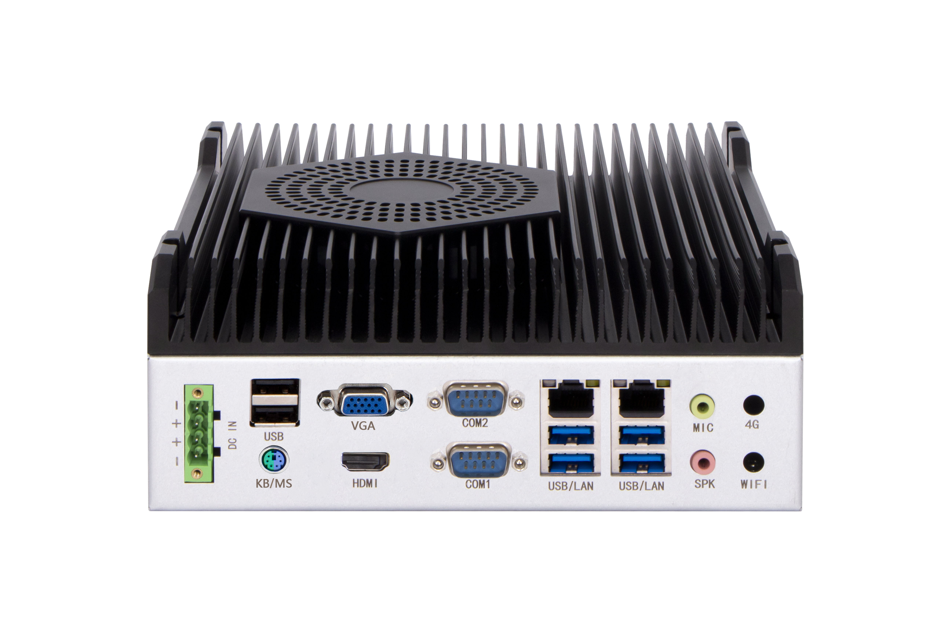
7.Picture of H610:
QY-B5900

8.Dimensions:

